|  |  |  |  |  |
| --- | --- | --- | --- | --- |
| EGC_Black | | Mathematics Essentials 2015  Unit 2: Test 1  Task Weighting: 13% | | |
| Student Name: |  | |  |

Time Allowed: 45 Minutes Total Marks: 45

**Calculators and files are allowed in this test.**

***Answer all of the following questions. Show all working to maximise marks.***

**Question 1** [5 Marks: 1, 1, 1, 1, 1]

From the lists of data displays and data types below, complete the table by choosing the most appropriate Data Display and Data Type.

**Data Types**

* Numerical
* Categorical

**Data Displays**

* Column graph
* Dot frequency diagram
* Back to back stem and leaf diagram
* Histogram
* Pie

|  |  |  |
| --- | --- | --- |
|  | **Data Display** | **Data Type** |
| The heights (measured in cm) of 20 boys and 20 girls to compare them. |  |  |
| The eye colour of all Year 11 students. |  |  |
| The foot length, measured in cm, of the members of your class |  |  |
| The percentage of students in each year at our school. |  |  |
| The birth month of all Essentials students. |  |  |

**Question 2** [6 marks: 1, 1, 1, 2, 1 ]

This dot plot shows the number of motor vehicle thefts in the Goldfields region of Western Australia recorded each month for one year.

**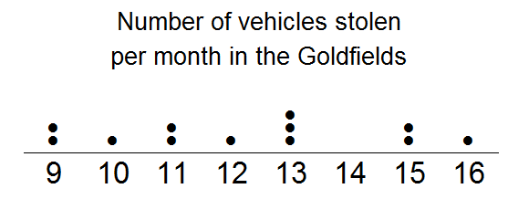**

a) Calculate the range of the scores, showing your working.

b) Determine the mode. \_\_\_\_\_\_\_\_\_\_\_\_\_\_\_\_\_\_

c) Determine the median. \_\_\_\_\_\_\_\_\_\_\_\_\_\_\_\_\_\_

d) Calculate the mean, showing your working.

e) Complete this sentence:   
For the Goldfields region, you would expect approximately \_\_\_\_\_\_\_\_\_\_ vehicles stolen within a month.

**Question 3** [4 marks: 2, 2]

Two classes are marked on the same tests.

* Class P has a mean of 65% and standard deviation of 5.
* Class Q has a mean of 50% and standard deviation of 15.

1. Write a statement comparing the scores of the two classes, who had the better scores and why?

1. Write a statement comparing the spread of the scores for the two classes and why.

**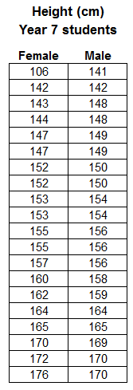Question 4** [17 marks: 2, 2, 3, 6, 4]

Consider the data to the right, showing the heights of 20 male and 20 female Year 7 students, taken from CensusAtSchool.

1. Circle or highlight any outliers in the data.
   1. For any you find, explain why you consider it an outlier.
2. Explain the effect the outlier(s) have on the:
   1. Mean
   2. Median

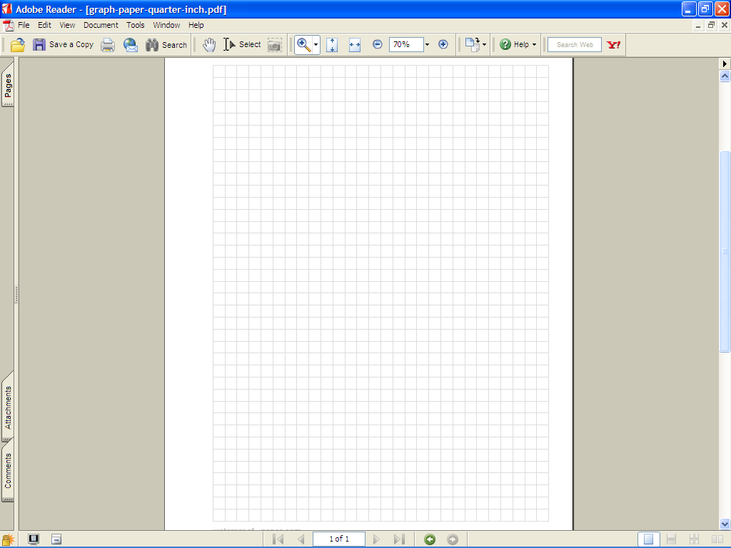

1. Make a back-to-back stem and leaf diagram to display this data.
2. Complete the table below, showing your working, to summarize the statistics for this data.

|  |  |  |
| --- | --- | --- |
| **Statistic** | **Female** | **Male** |
| Mode |  |  |
| Median |  |  |
| Range |  |  |

1. Using your stem and leaf plot and/or the table in d), compare the data for males and females.
   1. List two ways are the two groups similar?
   2. List two ways are the two groups different?

### Question 5 [13 marks: 1, 5, 4, 3]

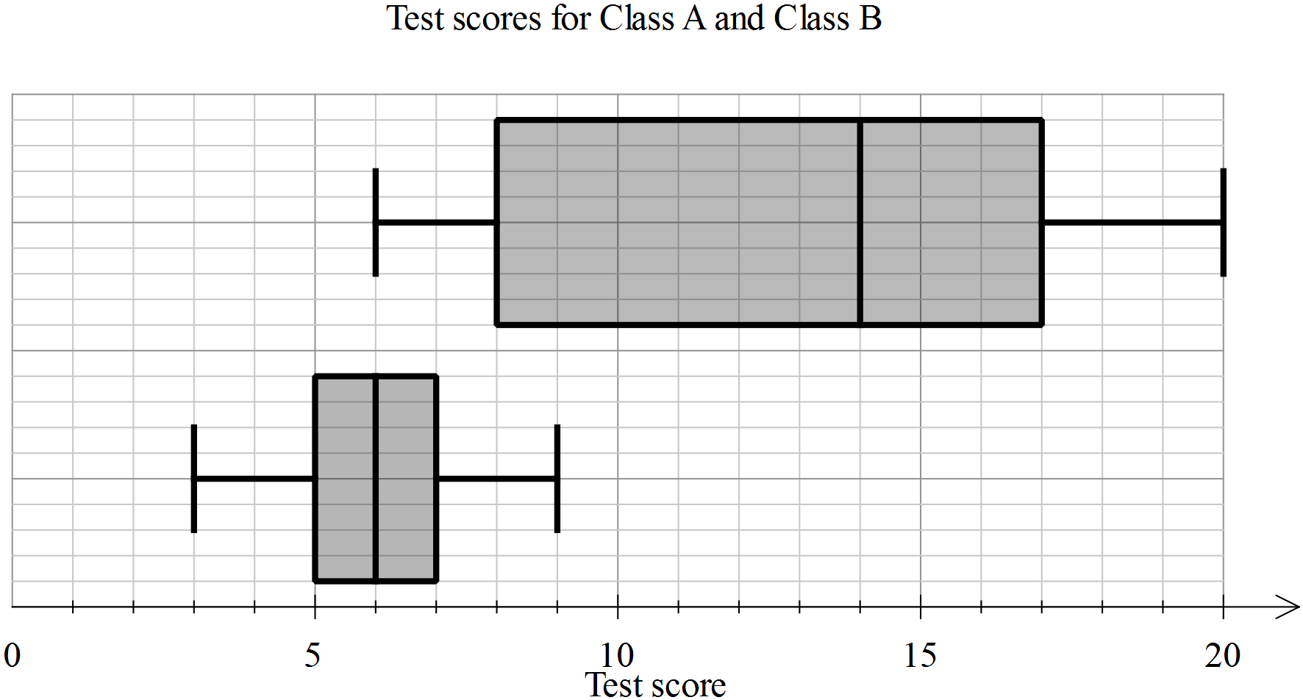

a) Eric is in Class A, he scored 5 on the test. **Label** **the two box plots** with their class names.

b) Use the table below to enter the appropriate values for each of the plots.

|  |  |  |
| --- | --- | --- |
| **Statistic** | **Class A** | **Class B** |
| Minimum |  |  |
| First quartile |  |  |
| Median |  |  |
| Third quartile |  |  |
| Maximum |  |  |

c) Calculate the range and interquartile range for each class, showing the working, in the table below.

|  |  |  |
| --- | --- | --- |
| **Statistic** | **Class A** | **Class B** |
| Range |  |  |
| Interquartile range |  |  |

1. In each of the statements below, write A and B as appropriate to make the statement true.

* Class \_\_\_\_\_\_ has a much greater range than Class \_\_\_\_\_\_
* The minimum for Class \_\_\_\_\_\_ is the same as the median for Class \_\_\_\_\_\_
* For Class \_\_\_\_\_\_, the data is symmetrical and for Class \_\_\_\_\_\_, 100% of the scores are greater than 6.

END OF TEST